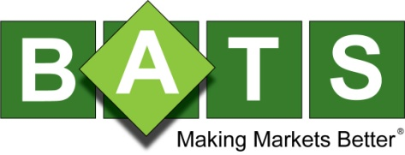
BATS SIFMA BCP Test Script Saturday, October 5, 2013
Overview
The BATS BYX Exchange, BATS BZX Exchange and BATS Options Exchange will be participating in the
Annual SIFMA BCP test which is scheduled to take place on Saturday, October 5, 2013 from 8:00AM – 1:00PM ET. All symbols will be made available for order entry. BATS systems will start up as normal and be made available for connectivity as early as 7:30AM ET. All Members are encouraged to participate in this Industry-Wide test which will allow for BATS Disaster Recovery testing as follows.

The BZX Exchange, BYX Exchange, and BATS Options will operate out of the secondary data center in Chicago for the SIFMA BCP test. Members with connectivity to the secondary site will be allowed to connect, submit orders, and receive market data for the duration of the test. For each member port in the primary data center there is an analogous port in the secondary data center that is ready for connection.

Registration
Members who wish to participate do not need to register with BATS.

Technical Support
The BATS Trade Desk (913.815.7001) and NOC (913.815.7005) will be available for support for the duration of the test.

For More Information
Please contact the BATS Trade Desk or your Director of Sales with any questions. We appreciate your continued support of BATS and look forward to earning more of your business. As always, we are committed to our Members and to Making Markets Better.
BATS Trade Desk
913.815.7001
tradedesk@bats.com
www.batsoptions.com/alerts
www.batstrading.com/alerts

